6.2β

Global Bike Sales Analysis in SAP Analytics Cloud

Nancy Jones, San Diego State University

Nitin Kalé, University of Southern California

### Objectives

This activity provides an opportunity to explore some of the various visualization and analysis functions of the SAP Analytics Cloud in the context of Global Bikes, a company you are already familiar with. The exercise is intended as a starting point; that is, students are encouraged to explore the other capabilities of the software and to extend their analysis of the Global Bike data past what is shown in this exercise.

### **Activities**

* Explore the data and data structures in the Global Bike model.
* Create a story using responsive pages.
* Create a geo map with two layers.
* Experiment with formatting, colors, and other styling components.
* Use linked analysis to link components of the stories.
* Create calculated measures.
* Create filters and input controls.
* Create and apply conditional formatting using threshold controls.
* Create a time series analysis.
* Create variance analyses.
* View story pages in various media formats.

### Prerequisites

* The Global Bike model built In Exercise 4.0 or a shared Global Bike sales data model.
* Access to an SAP Analytics Cloud tenant.

# Background

Global Bike sales data has been modeled in SAP Analytics Cloud. The model contains sales data from 2007 through 2019 for both the United States and Germany.

Hierarchies allow you to drill down to various levels of detail. The Global Bike model contains a hierarchy for Customer which consists of three levels: Country, Sales Organization, and MemberID. MemberID is the customer number in the data set. It links to the other properties of the Customer dimension.

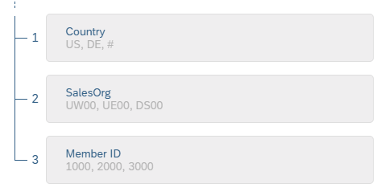

Figure 1: Customer Hierarchy

The Custom properties of the hierarchy include the customer geographic data down to the latitude and longitude level to allow you to create geo-enriched visualizations. The following attributes are contained in the Customer dimension properties:

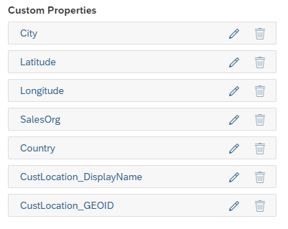

Figure 2: Customer Properties

Currency is also stored at the customer level. The U.S. customers use currency USD and German customers use Euros.

Another hierarchy of the model is for the date. You can create an analysis at year, quarter, month, and day levels.

The custom properties of the Product dimension also allow you to choose the level of detail for your analysis. The three levels of the hierarchy are shown below.

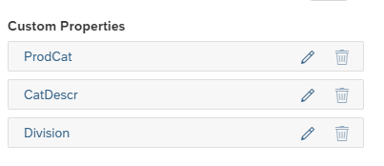

Figure 3: Product Properties

# Create a Story

Visualizations and analyses are created as stories in SAP Analytics Cloud (SAC). A story can have many pages and it can have many analyses on each page. How you organize your story is largely determined by the message you wish to convey and the analyses you wish to perform.

Your story may be viewed as is, similar to a slide show; it may be exported to a pdf or other format; it may used for a dashboard or digital boardroom; and it may be saved as a template. Stories do not need to be used in their entirety; that is, you may have some visualizations that were helpful in development of your data insights but are not particularly useful as a presentation.

SAC has built in analysis tools that use machine learning to suggest visualizations or analyses of your data. In this exercise, we focus on creating our own analyses and exposing you to many of the SAC capabilities. It only touches the surface of SAC’s features.

Good charting practice requires that all charts be named appropriately. For purposes of this exercise, title all charts and include your last name in all chart titles.

## Acquire Data and Start the Story

There is more than one way to start your story. This is just one of them.

Visualizations within the stories are created as either responsive pages or canvas pages. Responsive pages can be presented in various formats – they will adapt to the screen size. If you expect to present the story on various devices, perhaps on a phone or in a boardroom with big screens, then you would want to choose Responsive Pages. If you want pixel-perfect visualizations or if you do not need the pages to adjust to the display medium, then use Canvas Pages.

* + - 1. Create Story.
      2. Select Add a Responsive Page.

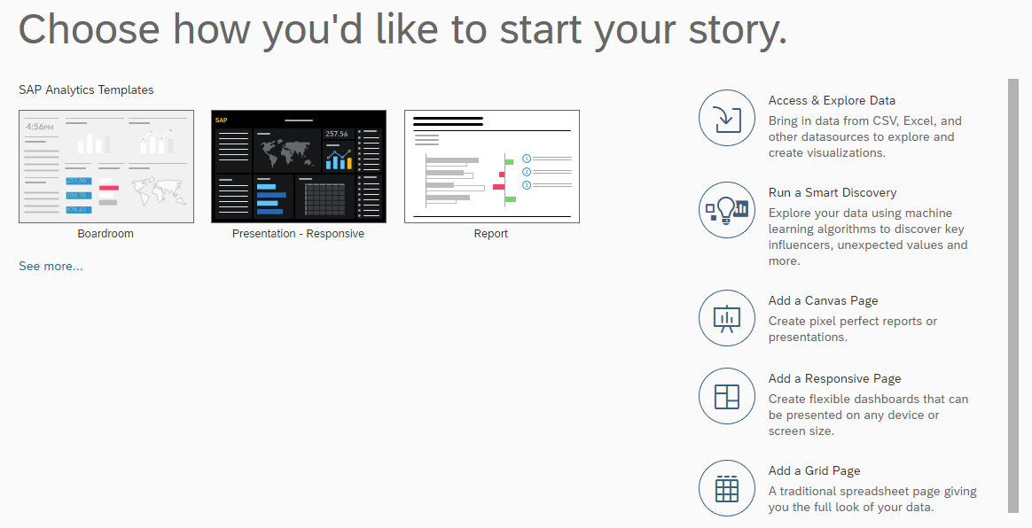

Figure 4: The Many Ways to Start a Story

Data for a story may be acquired via a live connection, importing of a data source(s), or data that has already been modeled in SAC. We will use the Global Bike model already created.

* + - 1. On the Data tab, choose Acquire from an existing dataset or model.

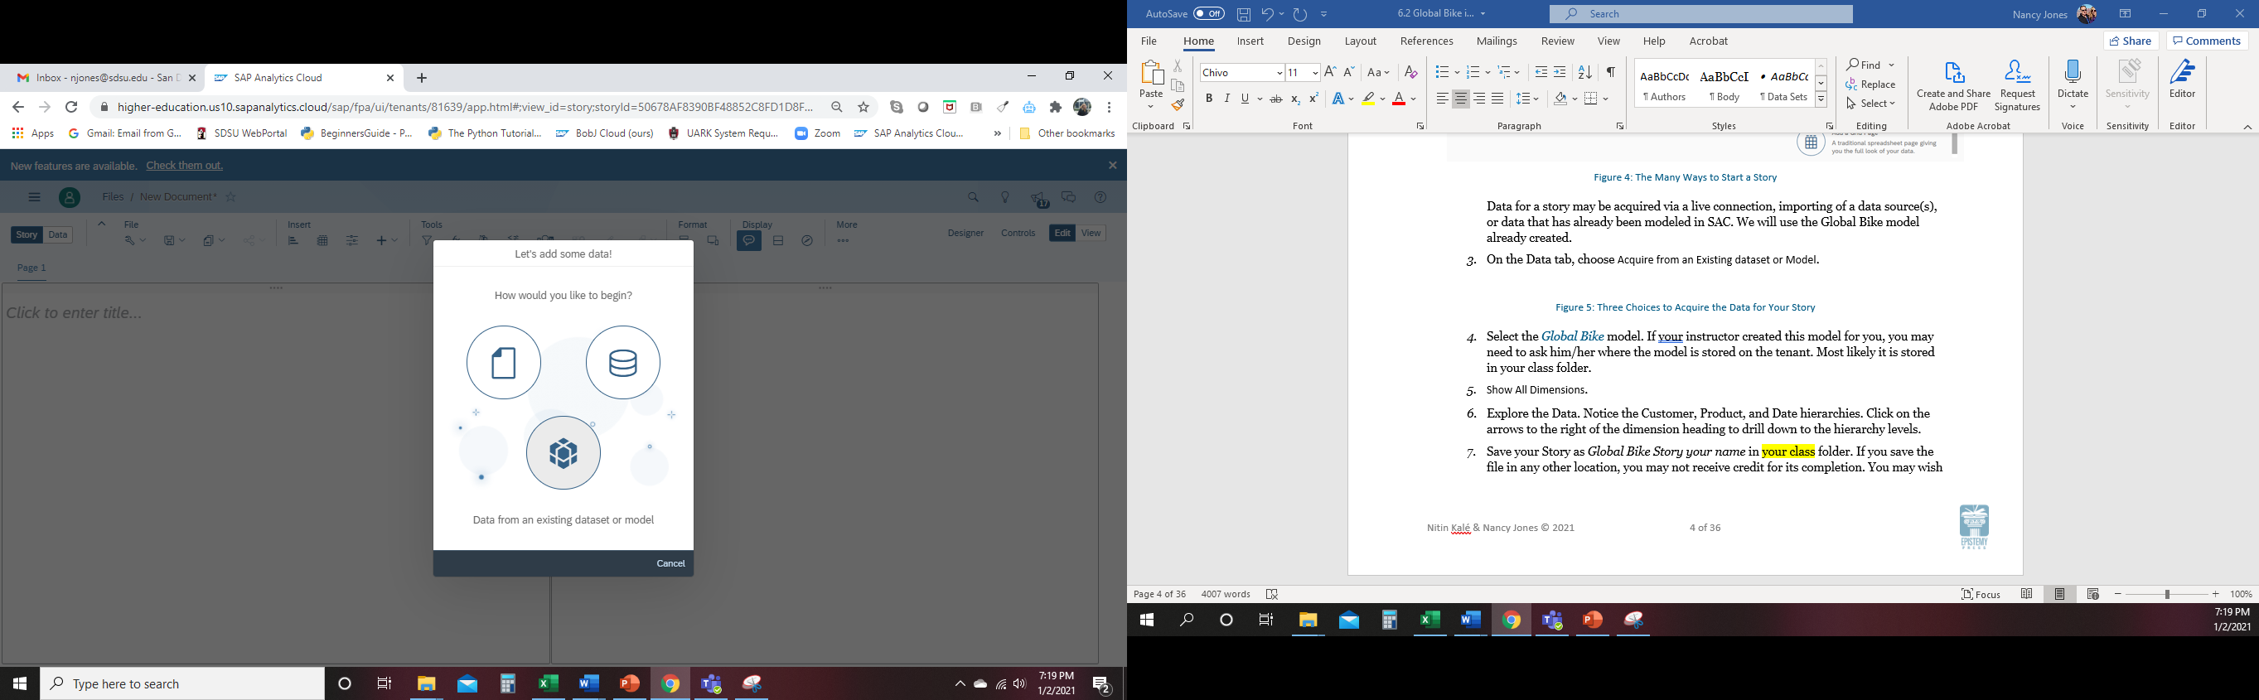

Figure 5: Three Choices to Acquire the Data for Your Story

* + - 1. Select the Global Bikes model. If your instructor created this model for you, you may need to ask him/her where the model is stored on the tenant. Most likely it is stored in your class folder.
      2. Show All Dimensions.
      3. Explore the Data. Notice the Customer, Product, and Date hierarchies. Click on the arrows to the right of the dimension heading to drill down to the hierarchy levels.
      4. Save your Story as *Global Bike Story your name* in your class folder. If you save the file in any other location, you may not receive credit for its completion. You may wish to save your story periodically and of course, after you finish it. SAC will actually warn you if you try to exit without saving.
         1. If the system asks you if you want to save or remove the model, choose save.

## Create a Geo-Map Page of Revenues in the United States

* + - 1. Go to the Story Tab. (The Story Tab is in the upper left corner of Figure 6.)
         1. The default view for a responsive page is two lanes arranged vertically. Lanes are used to organize content on multiple devices. If you were to create a canvas page, you would not see lanes.
         2. Each Lane can have its own style.
      2. You can add or delete lanes as you see fit.
      3. On one of the lanes, click to add a title Global Bike. (There should be a space after Bike.)
         1. To add text to the title that is generated by the story page, we use Add Dynamic Textfrom the … (*More*) choice on the chart actions drop down list shown in Figure 6. Select Add à Dynamic Text*.*

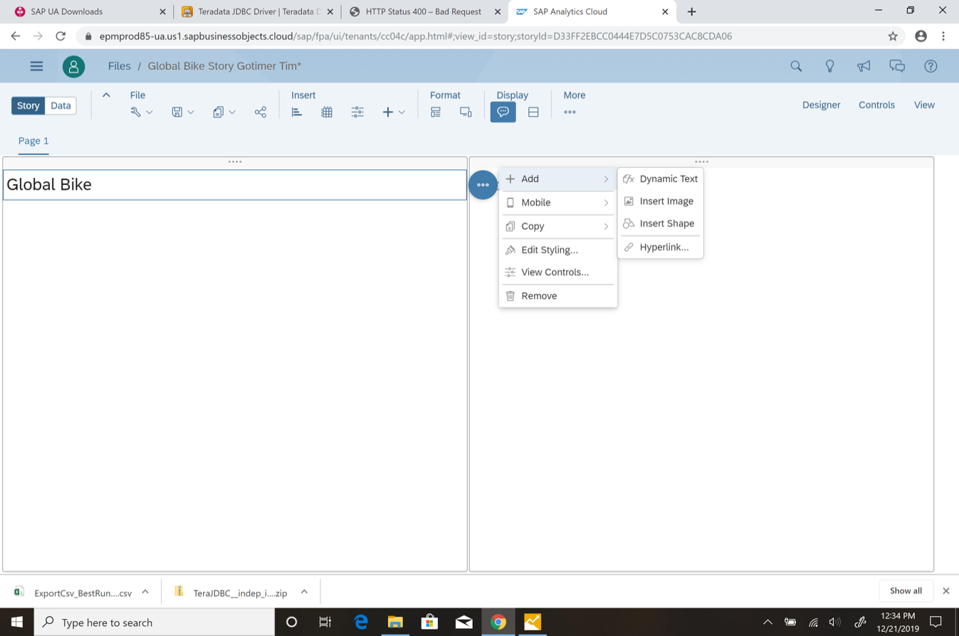

Figure 6: Add Dynamic Text

* + - * 1. On the Insert Dynamic Text Story Properties, choose Creator. The dynamic text creator is illustrated below in Figure 7. Notice that there are several choices as to what you would like to insert and where in your story page you would like to insert the text. Ours is a simple insertion of who created the story into the title.

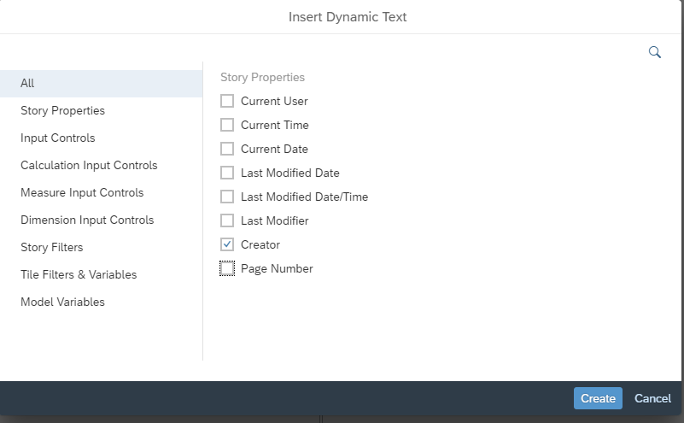

Figure 7: Insert Dynamic Text

* + - * 1. Once you have inserted Creator into the title, enter a space, the word “page” and then insert dynamic text Page Number.
        2. Edit the styling of the title. Perhaps change the font or color, add a background or borders.
        3. Your title will look similar to the following except it will of course have your user name and your particular style.

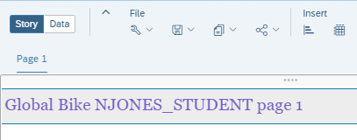

Figure 8: Dynamic Text in a Lane Title

* + - 1. Insert a Geo Map by choosing the Insert + and choosing Geo Map from the drop down list of options.

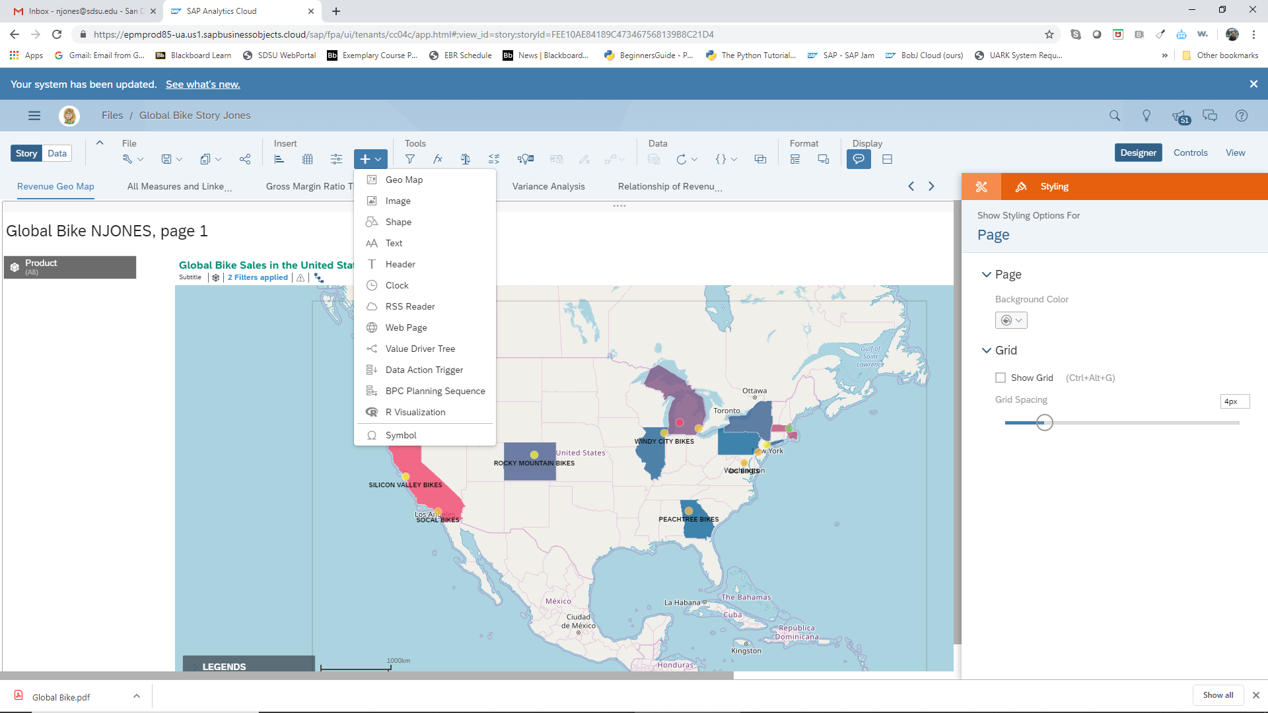

Figure 9: Insert Options

* + - 1. On the Designer Builder panel to the right of the chart and lanes, choose Basemap.
         1. Choose the style of the background, “base map” for your visualization.
      2. 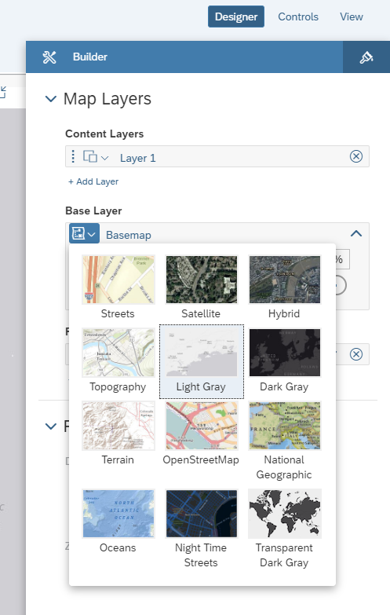

Figure 10: Geo Base Layer Options

* + - 1. + Add LayeràGeochoropleth/Drill Layer*.*

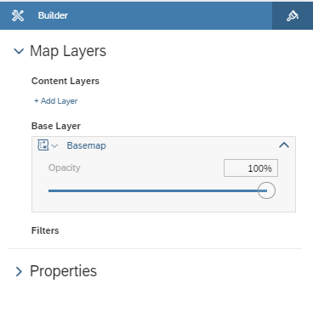

Figure 11: Designer/Builder Panel for a Geo Map

* + - 1. Geo data can be layered using multiple data sets or geographical sources. For example, you could use a different data model for layer 1 than for layer 2 and so on. We will be using the defaulted data model, Global Bikes.
      2. For this chart, we are interested in Revenues by location.
         1. Under Location Dimension, choose CustomerLocation. (It should be the only choice.)
         2. Under Choropleth Color, choose RevenueUSD.

Notice the warning in the upper left that this item has limited support on certain devices.

* + - 1. Change theRange to 5 and toggle to # instead of % as shown below. Feel free to experiment with different levels of granularity (fewer or more ranges) and with the % versus # settings. If you set the Ranges to 8, you will see more levels of granularity.

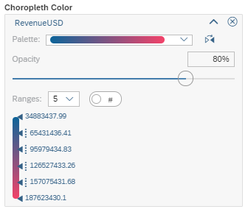

Figure 12: Choropleth Color Ranges

The following is the result at Ranges = 5.

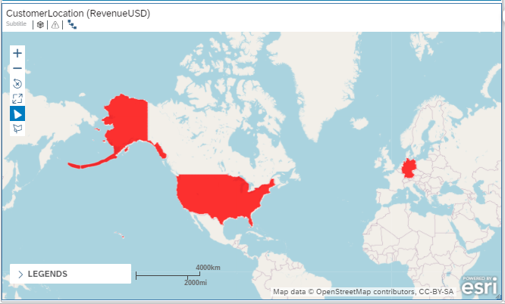

Figure 13: Geo Choropleth of Revenues in USD

* + - 1. Now change the hierarchy level by selecting the *navigate up/down hierarchy icon* at the upper left of the map.
         1. Select CustLocation à Region. The map will change to the following.

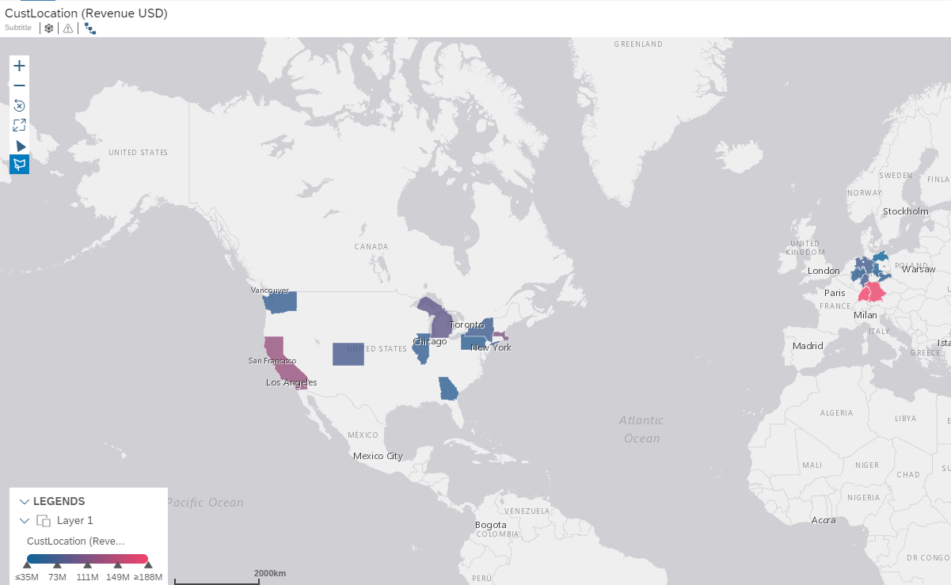

Figure 14: Change the Hierarchy of CustLocation

* + - 1. To zero in on the area of interest, in this case the United States, choose the polygon filter tool at the upper left of the map and highlighted in Figure 15. Choose the rectangle shape.

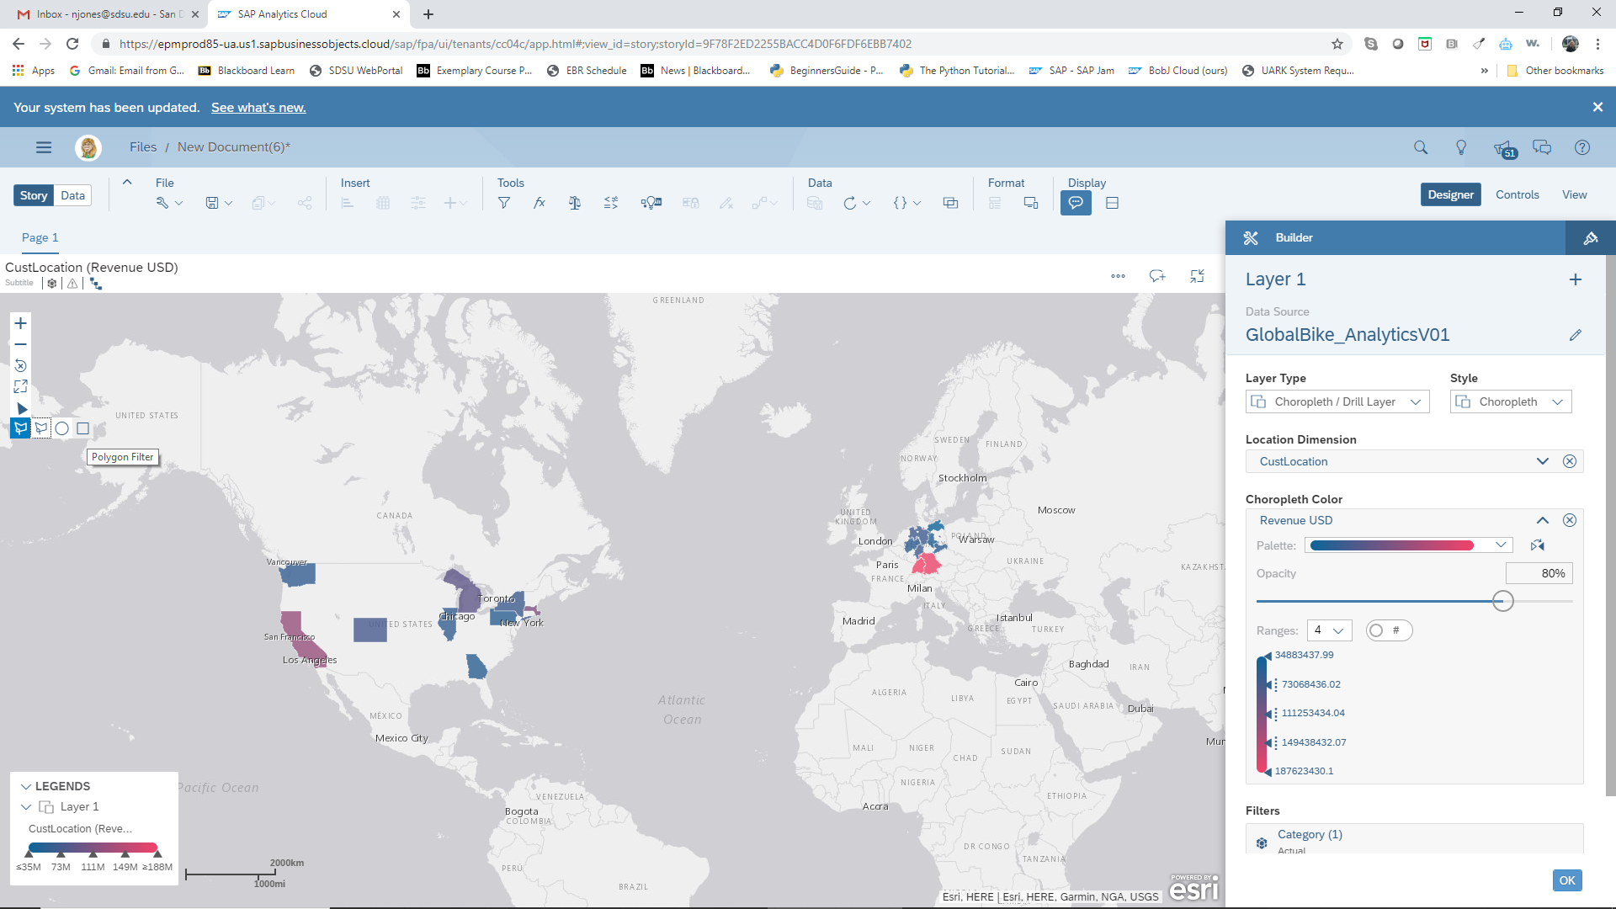

Figure 15: Filter Tools

* + - * 1. Draw a rectangle around the U.S.to filter to the continental United States.
      1. Now you will personalize the map.
         1. Under the Stylingpanel, change the display options of the Widgets and the text to a style of your choosing. For example, you can change background, text, borders, and legends. Note that borders are not supported for mobile devices but will be visible for other displays.
         2. Under the Builder panel, feel free to change colors of the ranges. You can see this option in Figure 12.
         3. Click OK to leave Layer 1 and go to the main Builderpanel. Here you can change the map background and other properties.
         4. Don’t forget to give your map a title.

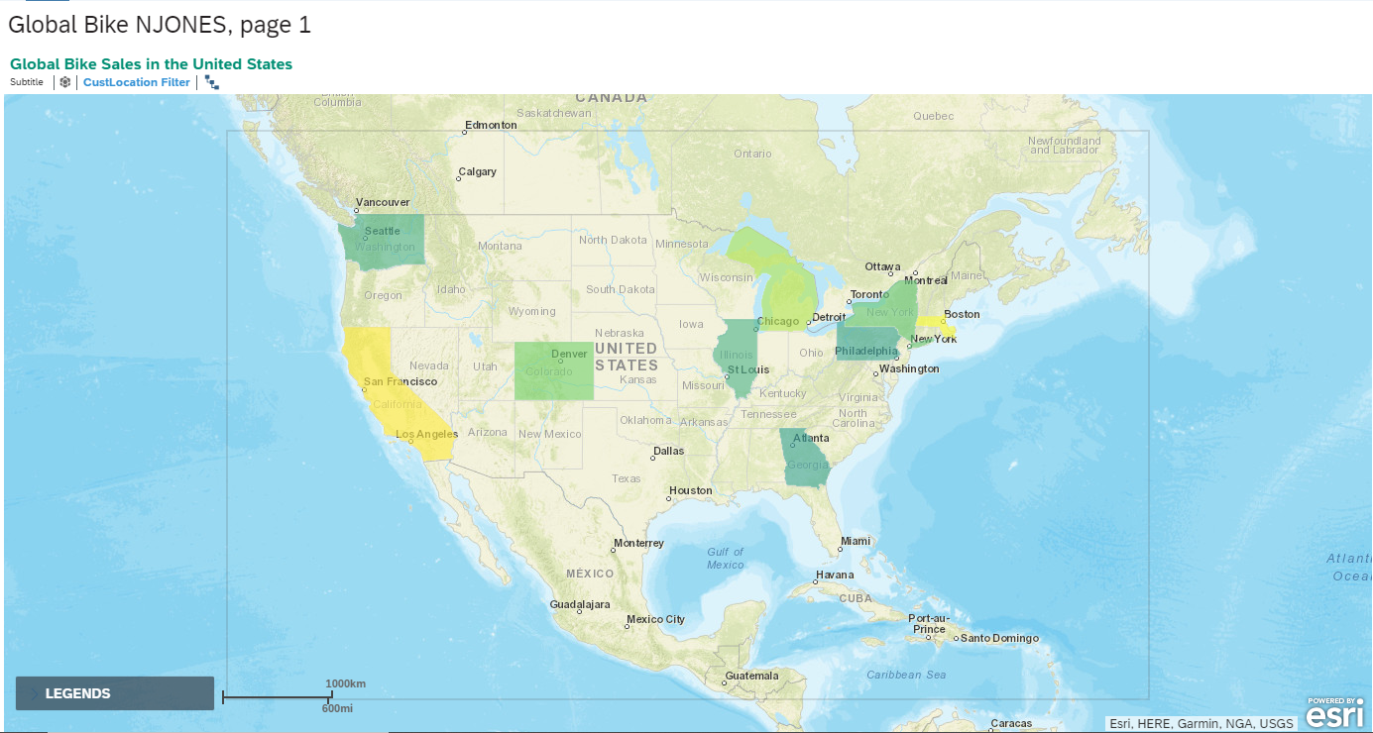

Figure 16: An Example of the Global Bikes Geochoropleth Map

* + - 1. You can also add layers. The chart in Figure 17 has two layers, the first is a choropleth for revenue and the second is a bubble map for Quantities Sold. The bubble color is from a different color panel than the choropleth layer.
         1. Add a Layer 2 of your choosing in the Builder panel by clicking on + Add Layer. Be sure to include CustomerLocation as your Location Dimension.

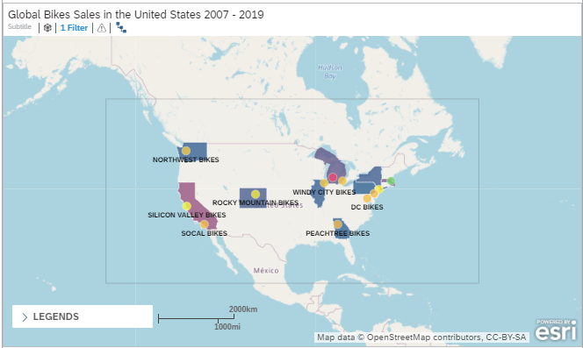

Figure 17: A Geo Map with Two Layers

* + - 1. We may want to analyze the geographic revenues by product. We can build an input control into the map to allow us to filter by various products. In this step, you will add a filter to your map for product dimension.
         1. Select the Input Control icon at the top of the page with the Insert widgets.

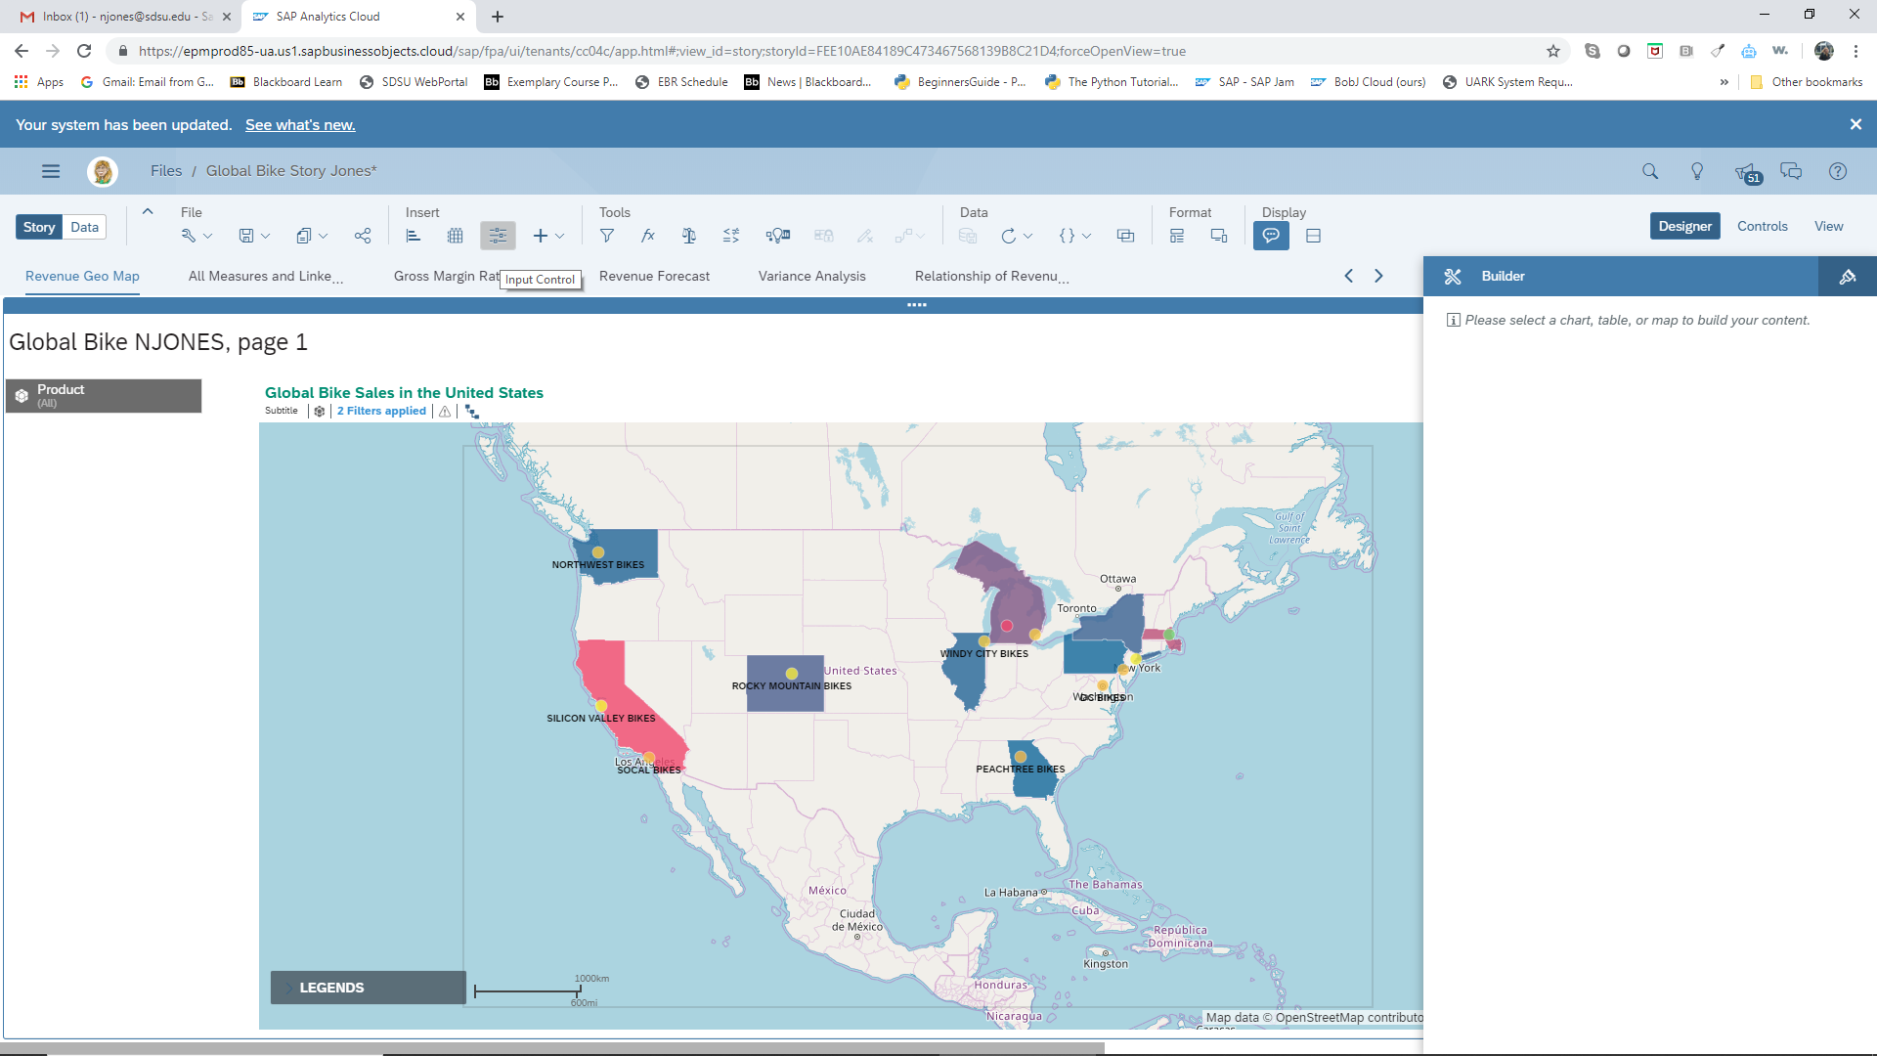

Figure 18: Insert Input Control

* + - * 1. Choose Dimensions à Product à Product (Dimension)
        2. Select the settings shown below in Figure 19.

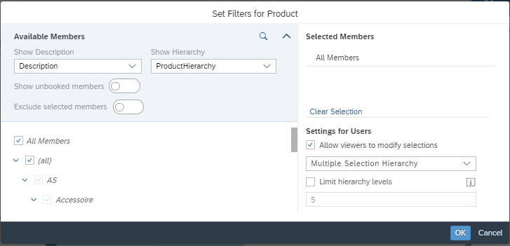

Figure 19: Product Filter Settings

The filter will be placed on the page next to the map. You have the option to expand the control and to move the control to where you want it on your page.

The input control filter you added is for the page. Any other charts that you place on the page, will be affected by settings of the input control filter. You might see how this would be helpful for “what-if” analysis using multiple charts.

* + - 1. Place a comment in the geo chart by selecting the chart and choosing Add Comment from the Action list.

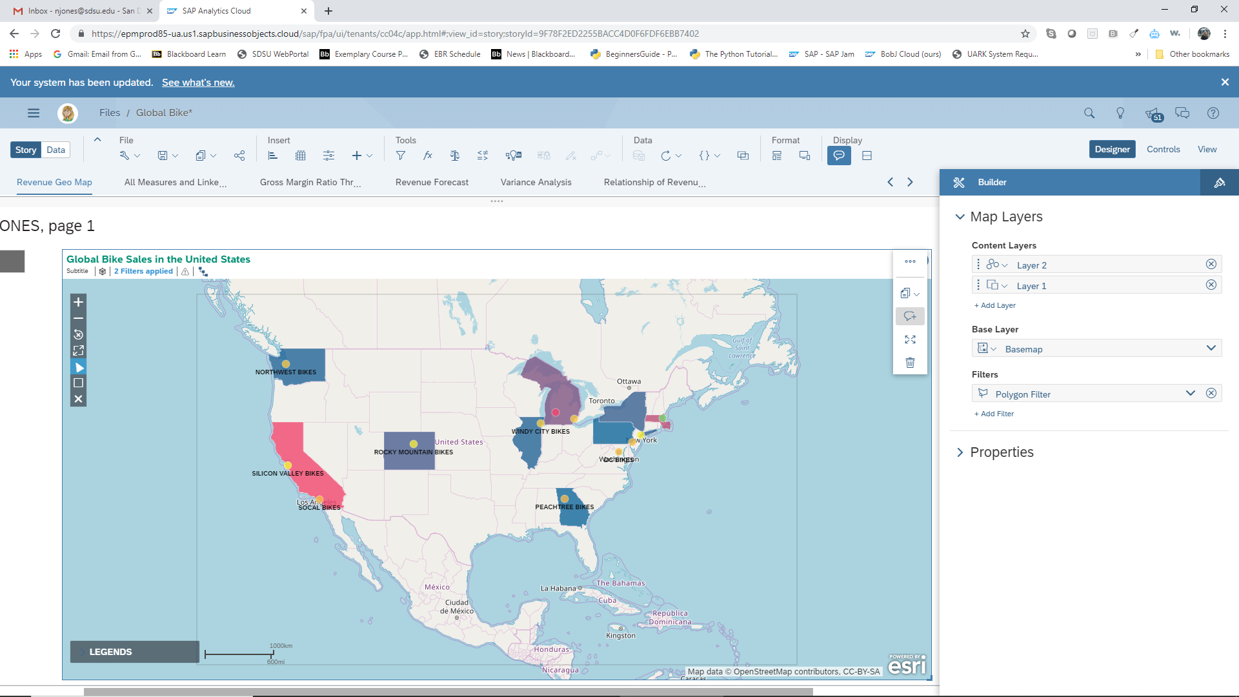

Figure 20: Add Comment Icon

* + - * 1. Type in your comment. You decide what you would like to type.
        2. Place Comment. The comment is now linked to this chart.

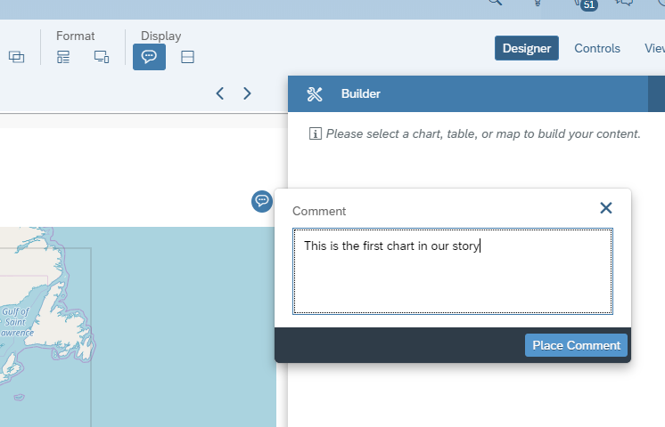

Figure 21: Adding a Comment to a Chart

## Demonstration of Linked Analysis:

Linked Analysis is a means to link the actions of one chart or widget to another so that changes made in one will affect the other. For example, drilling down on one component in a chart will cause the linked chart to also filter down to the same component.

For this analysis, we are interested in Gross Margin Ratios to see what customers and products are most profitable for Global Bike.

* + - 1. Add a Responsive Page to the Story. (Use the + next to Page 1.)
      2. On the first Lane, insert a table.
      3. Gross Margin Ratio is not a measure in the Global Bike data set. We will need to create a calculated measure for Gross Margin Ratio to do this analysis.
         1. On the Builder panel, choose Columns à Account à Add Calculation (see Figure 22).

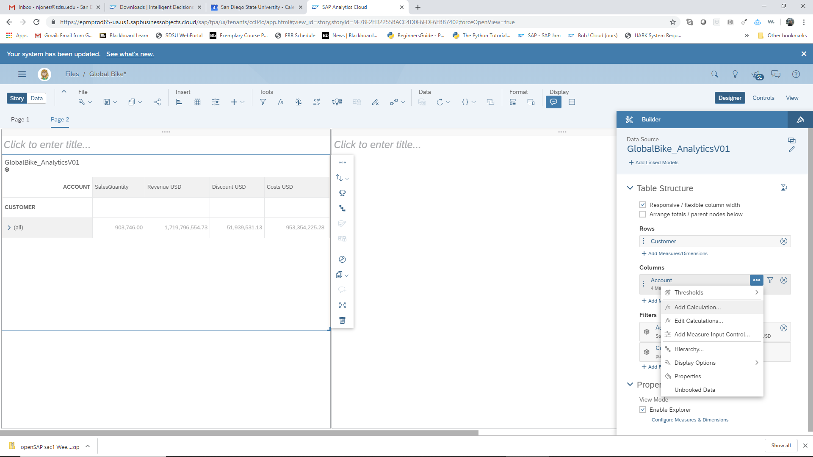

Figure 22: Add a Calculated Measure

* + - * 1. Using the auto fill properties of SAC, enter the formula for Gross Margin Ratio, (Revenue USD – Costs USD – Discounts USD) / Revenue USD * 100
        2. Name the calculated measure “Gross Margin Ratio”.
      1. Under Properties at the bottom right of the table builder, Enable Explorer. You will want to enable Explorer for all your charts to make them available for on-the-fly SAC driven exploration.
      2. Add Customer to Row. Notice that since the Customer is a hierarchy, you can choose the level of detail by expanding the Customer field (see > (all) in Figure 23).
      3. Add Measures (Accounts) Sales Quantity, Revenue USD, Discount USD, Costs USD, and (Calculation) Gross Margin Ratio to the Columns. A quick way to do this is to use the Columns filter.

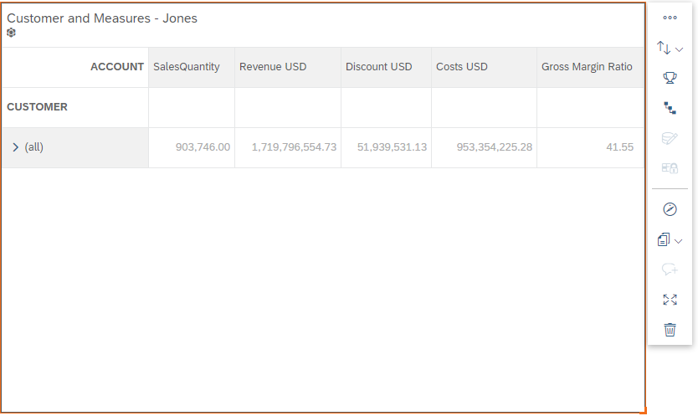

Figure 23: Creating a Table

* + - 1. Create a chart of Gross Margin Ratio by Customer. The example uses a bar chart.
      2. Now add Linked Analysis to the table by selecting the Table and using the … *More* drop down list on the Action panel to the right of the table.

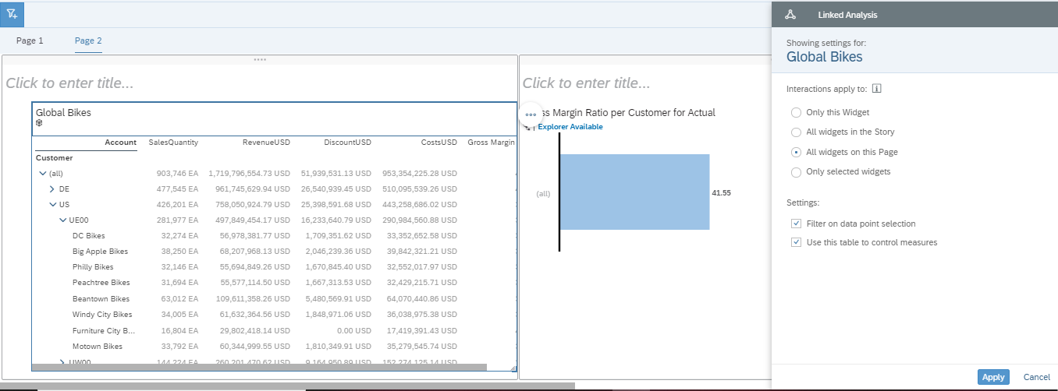

Figure 24: Adding Linked Analysis to the Table

* + - * 1. Complete the linked analysis as in Figure 24 above: Interactions apply to = All Widgets on this Page, and Settings = Filter on data point selection and Use this table to control measures.
        2. Apply.
      1. The linked analysis in the previous steps will cause the actions in the table to be reflected on the chart. To have the actions on the chart reflect on the table, we need another link. Select the chart and create the linked analysis on the chart. The settings are shown below.

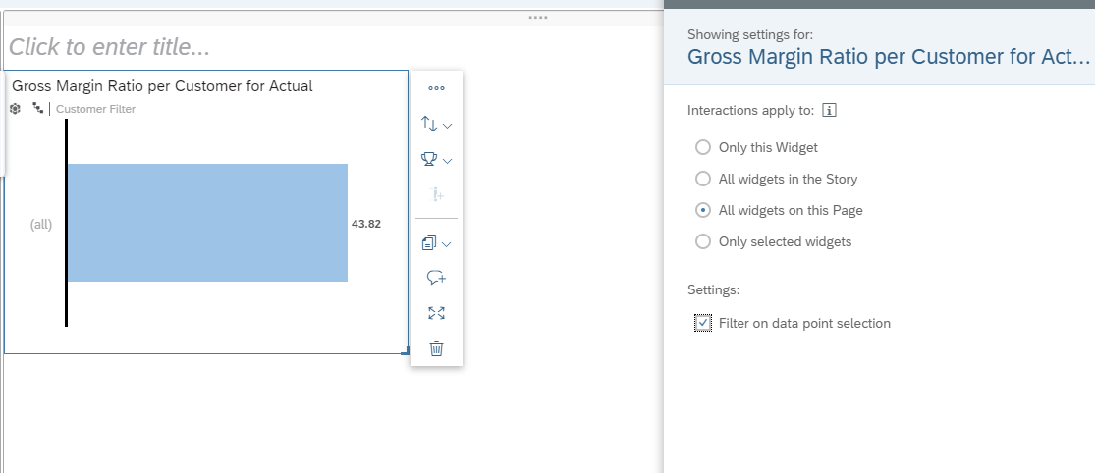

Figure 25: Adding Linked Analysis to the Chart

* + - 1. Expand the table and set the customer hierarchy level in the chart to level 4.
      2. Highlight the Customer or Sales Org of interest in either the chart or the table and watch what happens on the other visualization.
      3. Not available for tables or maps, but for all charts, you will want to Enable Sort Option in Boardroom, Enable Top N Option In Boardroom and Enable Variance Option in Boardroom to provide more interactivity for your presentations. The options are found on the Styling panel as shown in Figure 26.

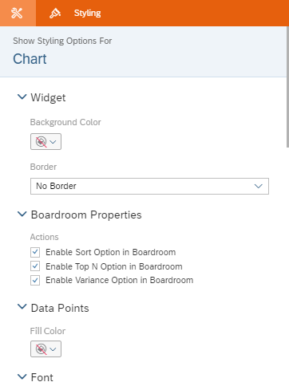

Figure 26: Enable Sort and Top N for the Boardroom

## Conditional Formatting

In SAC, Conditional Formatting is created using Thresholds. We wish to highlight Customers or Products at various Gross Margin Ratio levels to determine which are most profitable to Global Bike, so we will add some threshold formatting to our charts.

* + - 1. Add a New Responsive Page.
      2. Create a Bullet Chart of Customer (GEOID level) and Gross Margin Ratio in the first lane.
      3. In the Builder panel, go to Color and add a threshold by clicking on + Add Threshold.

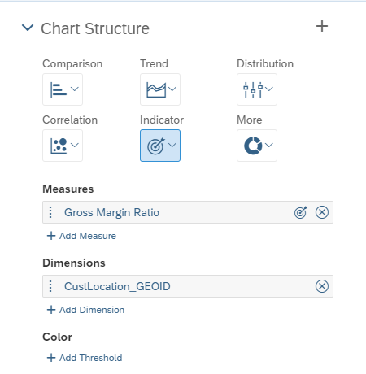

Figure 27: Add a Threshold

* + - 1. Complete the threshold settings as shown in Figure 28. Compare To = Number Range, Ranges = 50 to Max, 45 to 50, 40 to 45, and 0 to 40. You may choose whatever colors and shapes you would like to use for the ranges.
         1. Apply.

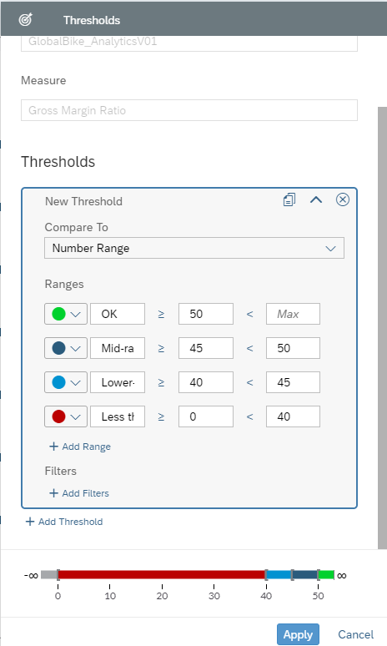

Figure 28: Setting up a Threshold

Your bullet chart should now look similar to the one shown in Figure 29 below. Notice that the chart has been auto ranked because there was not enough room on the screen for all the customers.

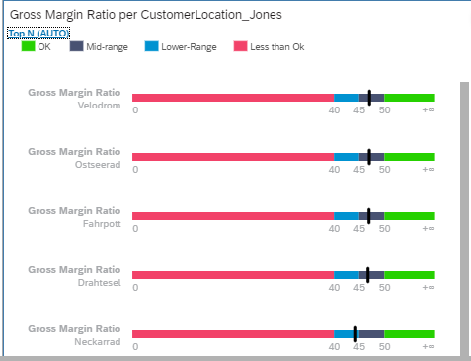

Figure 29: Customer Bullet Chart with GM Thresholds

* + - 1. Copy the bullet chart to the next lane. A quick way to copy is to use the Actions dropdown on the chart, Copy, and then click on the next lane and paste (CTRL-V).
         1. Change the dimension from Customer to Product. Choose all levels of Product.
      2. Sort Product ascending to get an alphabetical listing of the products.
      3. Sort Gross Margin ascending to see which products have the lowest gross margins. Are there any in the red? Are there any products in the green?
      4. Add a shape to the title lane of your bullet charts.
         1. You can find shape under+ à Insert Shape as shown in Figure 30. Then just choose a shape.

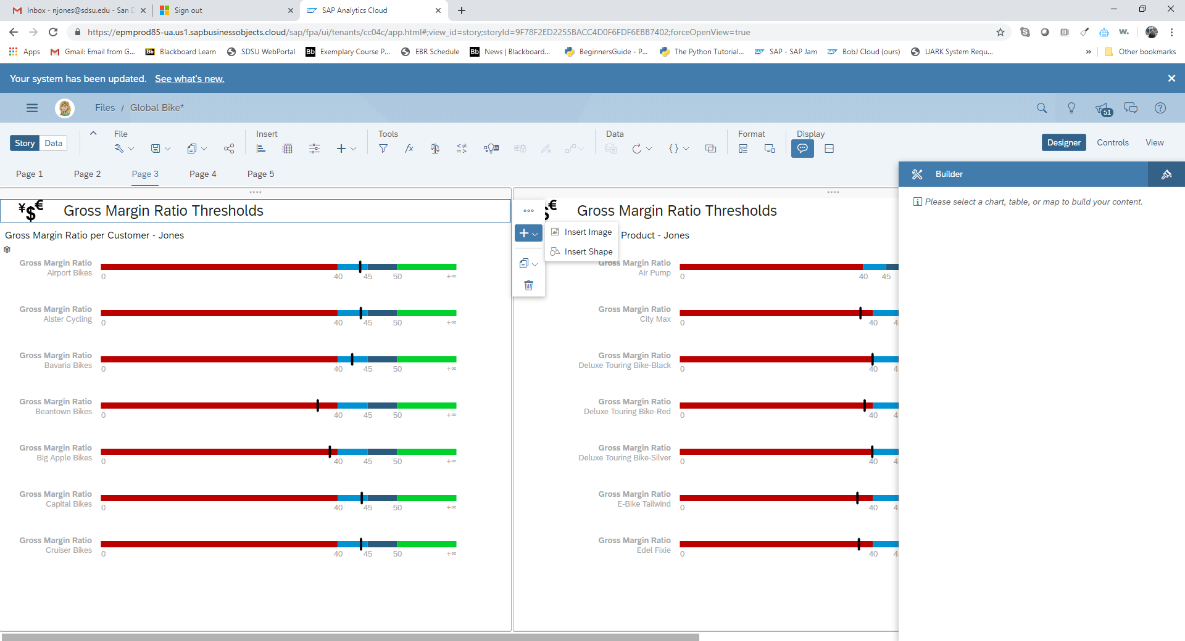

Figure 30: Insert a Shape

## Time Series Analysis

SAC has a few time series options built into the visualization tool. You can create regressions, forecasts, and exponential smoothing forecasts. The data must have a date variable for the trend analysis and forecasts to work.

* + - 1. Create another Responsive Pagein your Global Bike Story.
      2. Add a Chart.
         1. Add date as the dimension and Revenue USD as the measure.
      3. Change the chart to a time series. Notice that you have a choice of how granular you wish your time series to be. The chart shown here is for all time periods; that is all days, months, and years. You can adjust the time frame shown in the chart by dragging the blue-lined date “box” underneath the visualization.

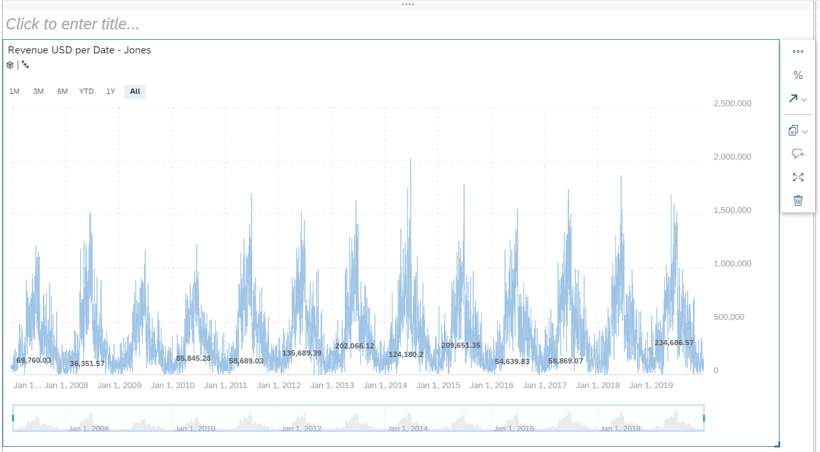

Figure 31: Time Series by Days, Months, and Years

* + - 1. Click on the Add Forecast on the Actions menu of time series chart within the red circle on Figure 31.
      2. Choose Automatic Forecast. When the Forecast completes, click on the word Forecast at the top left of the chart. Notice the quality of the model.
      3. Change the forecast to use Advanced options, Triple Exponential Smoothing.
         1. Change the slider to show only the more recent dates of the time series.
      4. 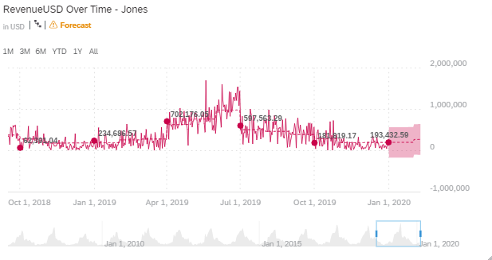

Figure 32: A Forecast to April 2020

* + - 1. Select the Add Forecast icon, Advanced Options à Linear Regression. The results should look similar to Figure 33 (except the color palette is not the default). Notice the upper and lower confidence boundaries.

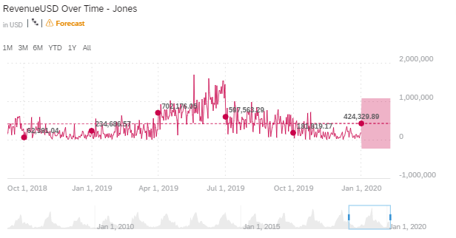

Figure 33: Regression Results

* + - 1. Again, using the Advanced Options of Add Forecast, choose Triple Exponential Smoothing. The results will be similar to those in Figure 34. Again note the upper and lower confidence boundaries.

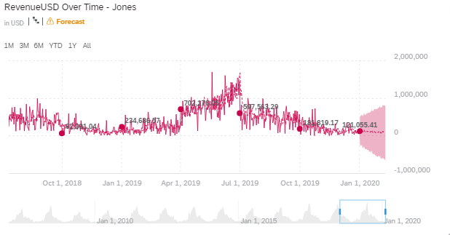

Figure 34: Exponential Smoothing Results

1. Why are the upper and lower boundaries farther apart the further into the future we predict?
   * + 1. Save the results of the Exponential Smoothing time series analysis.

## Variances

Variances are important management tools to help drive efficiencies and profitability. They may be visualized in various ways. Here are two examples of variance analysis in SAC.

* + - 1. Add another Responsive Page. This should be your 5th page.
      2. Insert a column chart in the leftmost lane of the page, (vertical orientation).
         1. Add SalesQuantity to Measure*.*
         2. Add Product to Dimensions.

Expand the product hierarchy to level 4.

* + - 1. Add a Reference Line to your chart. You will find Add a Reference Lineunder … More Actions on the chart.
         1. Choose Dynamic.
         2. Select Measure = SalesQuantity, Aggregation = Average as shown below.

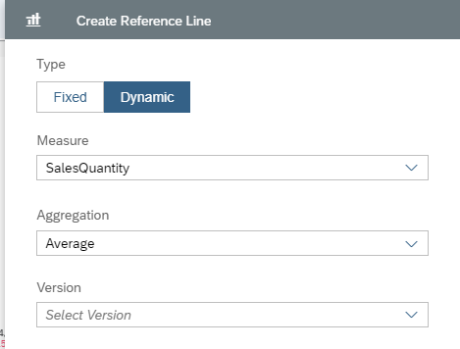

Figure 35: Settings for the Reference Line

* + - * 1. OK. The results should look similar to those in Figure 36.

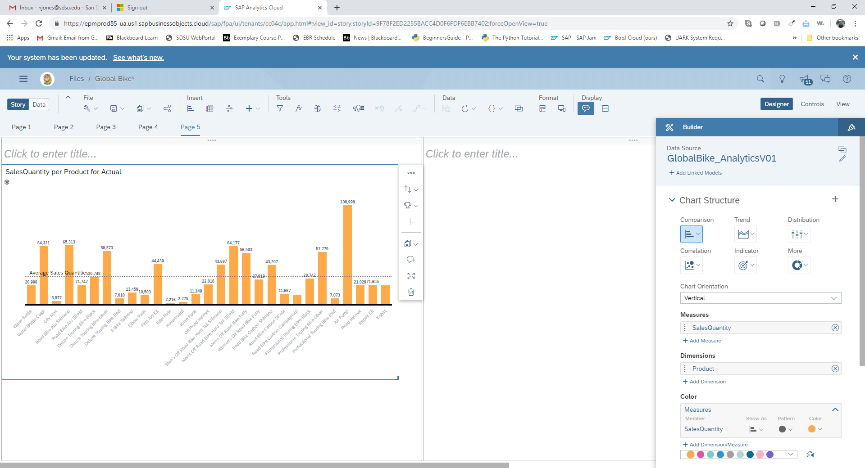

Figure 36: Sales Quantities by Product with a Reference Line

* + - 1. On the same lane, insert another chart, numeric point.
         1. Add SalesQuantity to the Measure.
         2. On the chart Actions dropdown, Add a cross calculation. You will now see the Cross Calculation option on the Builder panel. Create Cross Calculation. The settings are listed below and shown in Figure 37.

Type = Aggregation

Operation = AVERAGE

Aggregation Dimension = Product

Name = Average or Average by Product (you choose)

Measure = Account Values

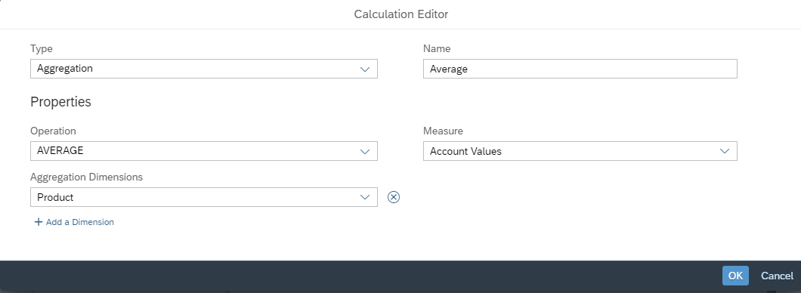

Figure 37: Calculation Settings

The value in your number chart should change from total to average.

Change the Decimal Places of Average to 0, (in Styling).

* + - * 1. Rename the title of the number chart.
        2. Resize your number chart and hide the primary value Labels. You can see where to find the Hide feature in Figure 38.

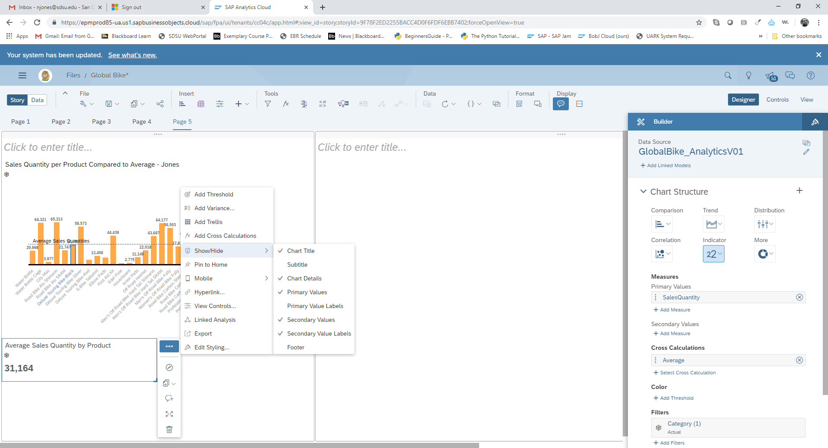

Figure 38: Hide/Show Chart Components

* + - 1. Add an Input Control (with the Insert widgets on the top ribbon) using the following selections:
         1. Page Filter.
         2. Dimensions.
         3. Date.
         4. Filter by range.
         5. Change type to Dynamic.
         6. Check to be sure your settings match those in Figure 39.

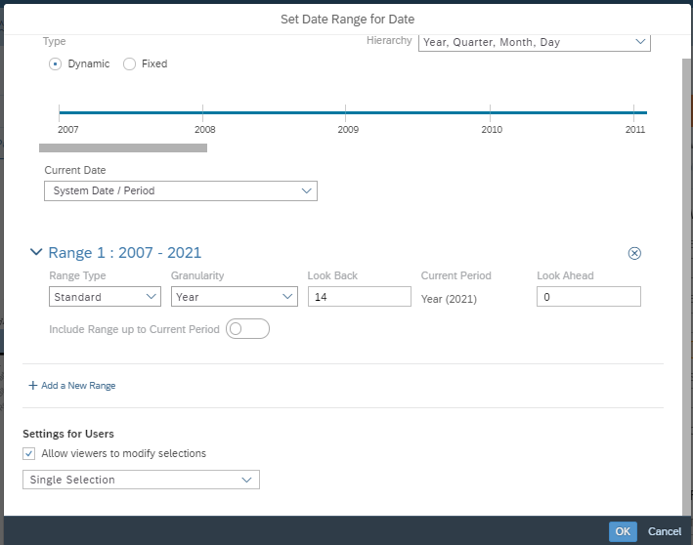

Figure 39: A Date Filter by Range

* + - * 1. OK.
        2. You can double click on the name of the control to change its name. I changed mine to say “Choose the Date Range”.
        3. Try out the Input Control and watch the change in the chart.
      1. On the right hand lane of your page, add a column chart to show Costs USD and Revenues USD by Sales Organization (SalesOrg).
      2. On the … More action selection, chooseCompare To à Open Variance à Open Variance Panel. The option is shown in Figure 40.

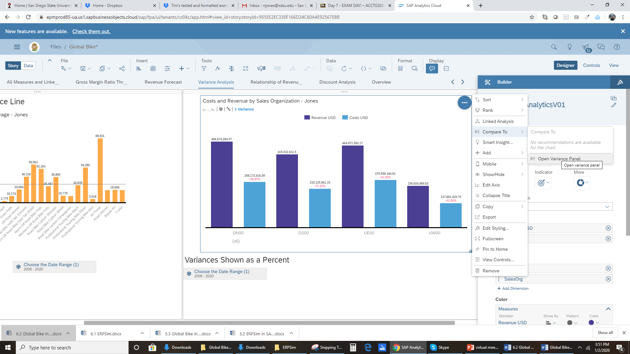

Figure 40: Add a Variance to the Chart

* + - * 1. Create your Variance to compare Costs USD to Revenue USD, show as a percentage with 2 decimal points. Display on Costs USD. These settings are shown in Figure 41.

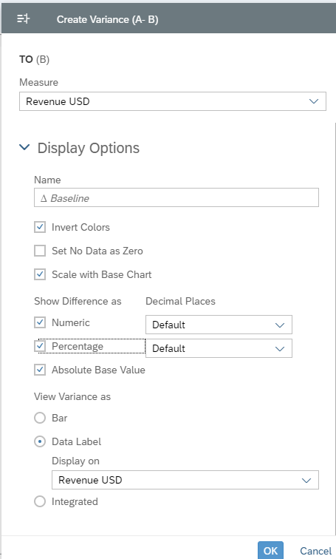

Figure 41: Variance Settings

* + - * 1. OK.
      1. Copy your date range input control from the first chart in the first lane to the new chart in the second lane.

## Create some more charts for the digital boardroom

* + - 1. Add another Responsive Page to your story (page 6)
      2. Delete the second lane. The first lane will take up the entire page.
      3. Add a chart to the lane.
         1. Create a bubble chart of Revenue USD, SalesQuantity, and Customer. Revenue USD on the x-axis, SalesQuantity on the y-axis, and Gross Margin Ratio as bubble size. Use Customer as the dimension and the color.
         2. Filter to the year 2019.

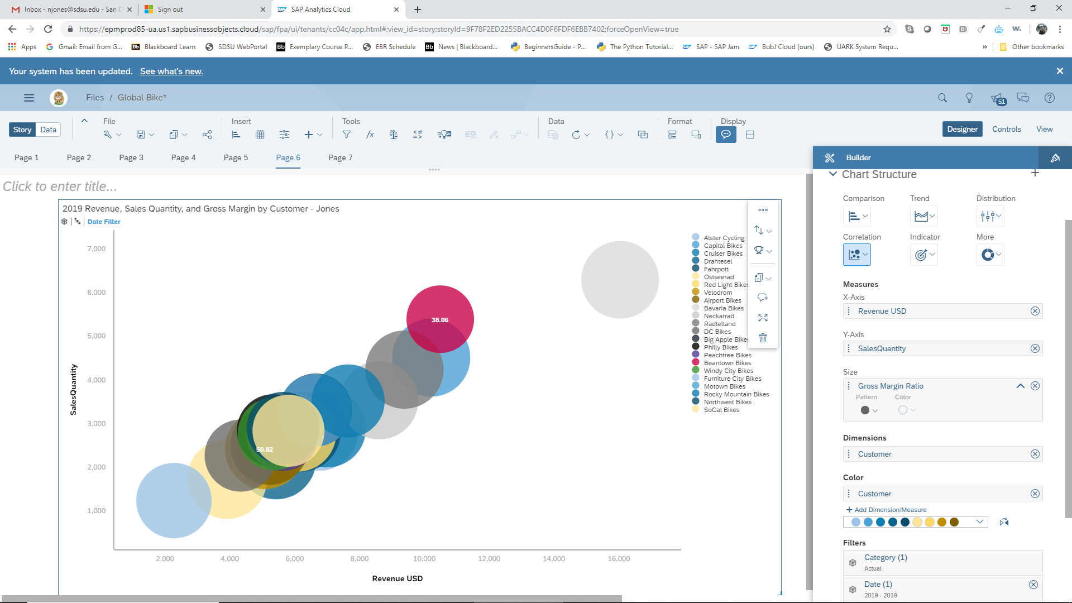

Figure 42: Bubble Chart of Quantity, Revenue, Gross Margin Ratio by Customer in 2019.

* + - * 1. Use Styling to add the high/low data labels by Gross Margin Ratio to the bubble and move the legend to the right side of the chart.

You may need to Show the Data Labels under Chart Actions, Show/Hide.

* + - 1. Add a 7th Responsive Page and create a chart of your choosing to compare discount as a percent of sales by SalesOrg. You will need to create a calculated measure for Discount USD divided by Revenue USD * 100. The formula is shown below.

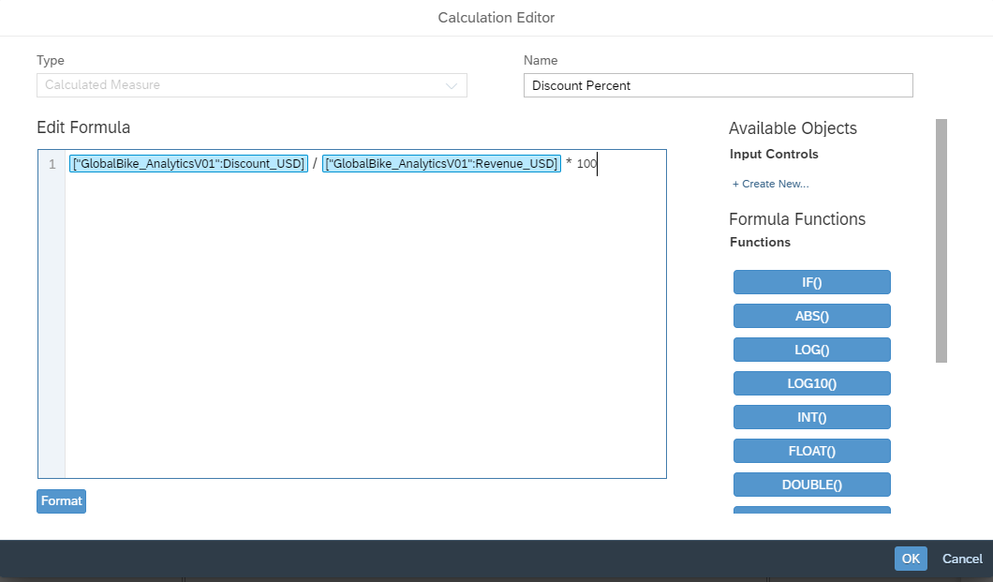

Figure 43: Discount Ratio Formula

* + - 1. Continue the comparison for discount as a percent of sales by Customer name and also by Product. You have several options. For example you could use input controls or multiple charts to create the variations. The following is an example only. It uses a Marimekko chart, a trellised bar chart, and a heat map. Use your own visualization/charting prowess to create your analysis.

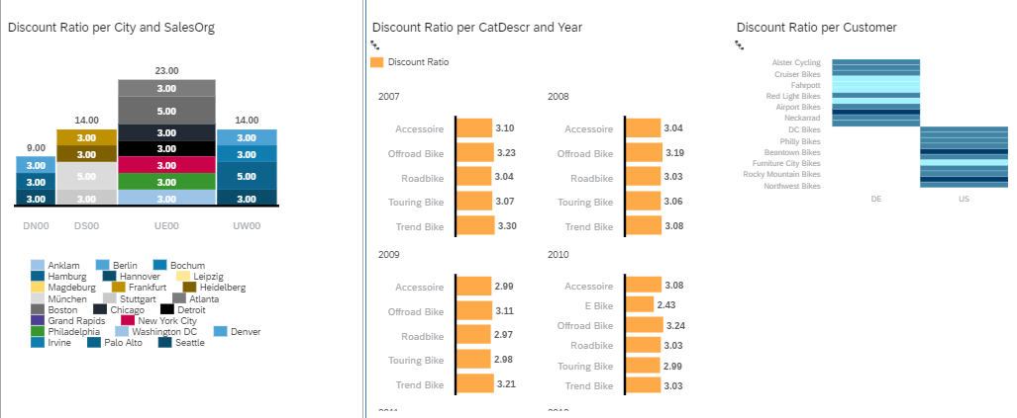

Figure 44: Example of a Discount Analysis

* + - 1. Finally, to pull the financial measures together, create one final Responsive Page.
      2. Create a waterfall chart using the following inputs. You will need to create a calculation for Gross Margin USD. The formula is Revenues USD – Costs USD – Discounts USD.
         1. Measures:

Gross Margin USD

Costs USD

Discount USD

Revenue USD

* + - * 1. Dimension = Date.

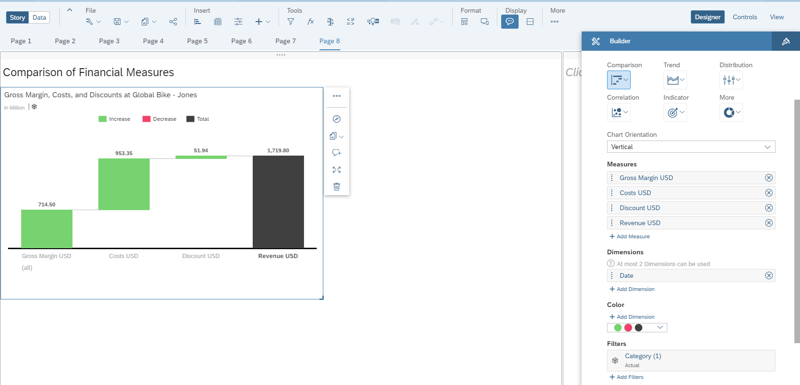

Figure 45: Waterfall Chart

## Viewing the Story and Tying up Loose Ends

* + - 1. To see how your pages will look on another device, go to Format on the top ribbon and choose Device Preview. You can change the device and size using the dropdown arrows shown below.

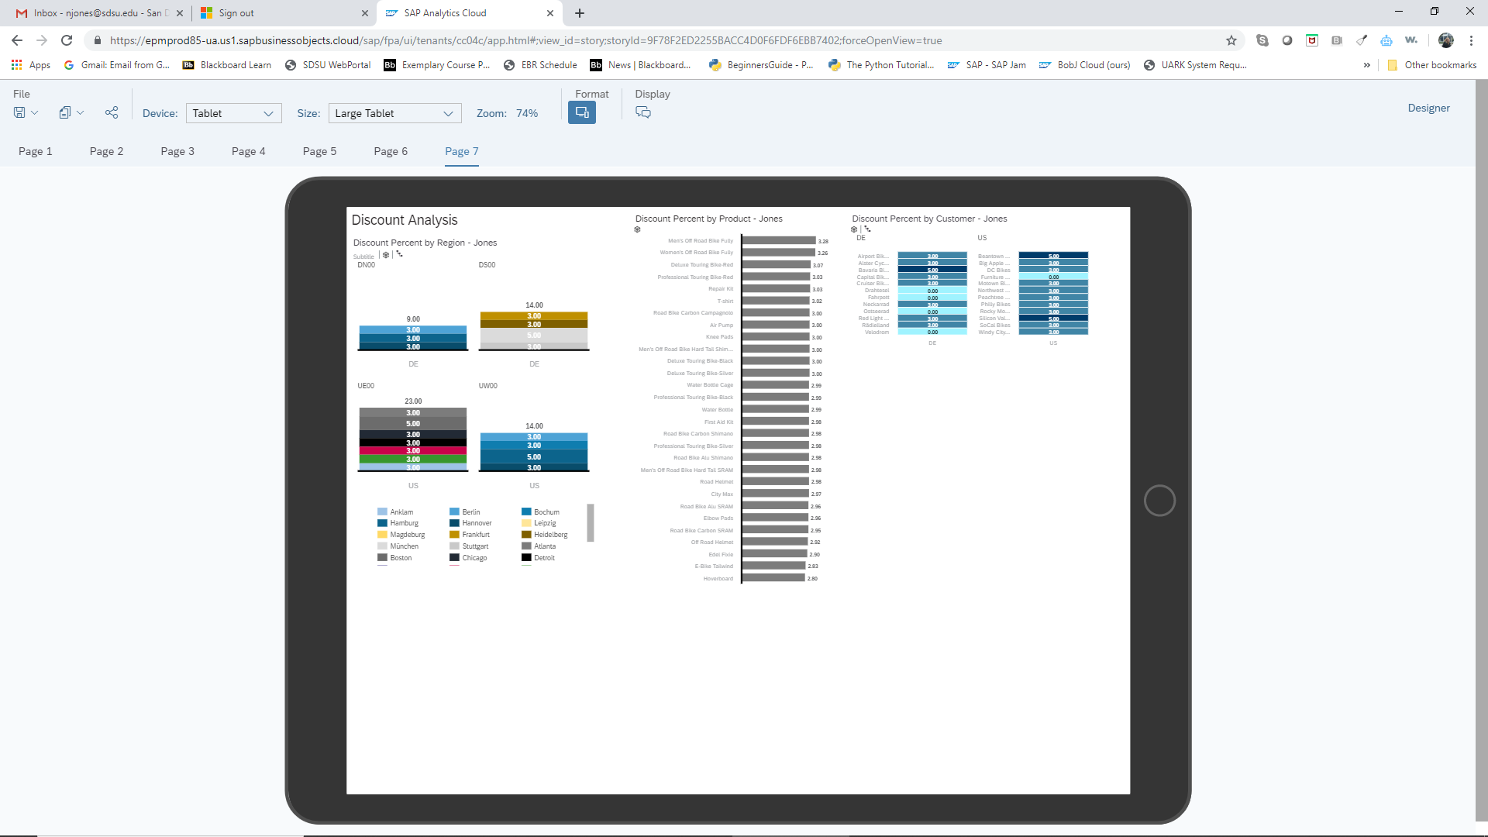

Figure 46: View of the Charts on a Tablet

* + - 1. Make sure all your charts have titles and you have enabled sort and top N options in the Boardroom.
      2. Save. Note: The visualizations you create here may be used in a future assignment.
      3. Export your file as either a pdf or Powerpoint slides by clicking on Save à Export. (Exporting as Google slides requires additional authorizations.)

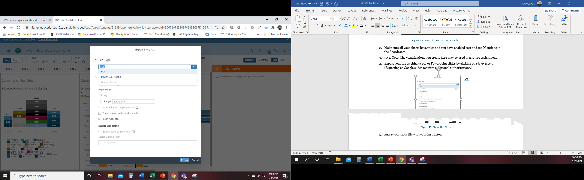

Figure 47: Share the Story

* + - 1. *Share* your Story file with your instructor.

# Challenge Activity

Create a visualization unlike any of the previous charts to analyze all measures of the data set by various attributes. Make your visualization interactive so that users can change parameters to slice and dice in various means. Be sure to use the proper chart type and formatting.